**How to Calibrate 10X attenuator boards for XIAO SAMD21 and RP-2040:**

These steps can also be used to calibrate any external resistor divider that might be used in conjunction with a data acquisition board that is controlled using the ALICE Universal software.

**Required Material:**

1. A Voltage source such as a 9 V battery. 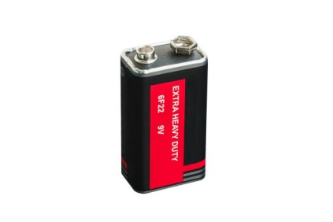

(Battery connector with jumper wires may be required)

2. A Digital Multimeter (hand-held DMM).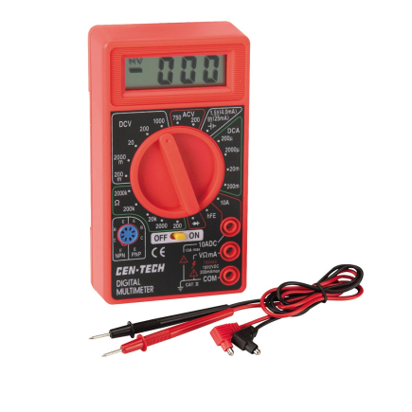

**Using the ALICE software Gain and Offset adjustment settings:**

The first step is to measure the 9 V battery voltage using the hand-held DMM. Set the DMM to measure voltage on the 20 V range if your meter does not have an auto-range function. Connect the + (VΩmA) input test lead of the DMM to the + terminal of the 9V battery. Connect the – (COM) input test lead of the DMM to the - terminal of the 9 V battery. **Write down the voltage**. You will be using this voltage as the calibration standard. (For this example the measured voltage was 10.03 V). You will not need the hand-held DMM after this step, only the measured battery voltage you just wrote down.

The next step is to calibrate (adjust) the Offset. Using male jumper wires connect the A+ and A- inputs to ground (GND pins). Run the ALICE software.

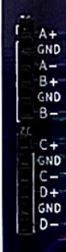

As a rough first guess, in the main ALICE screen, set the CA-V Gain entry to 10 and the Offset entry to 1.65 (detail shown below). Clicking on any of the channel buttons to the left of the entry spaces will reset the values to 1.0 and 0.0.

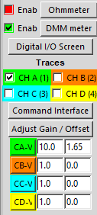

Opens ALICE DMM Analog Meter Virtual Instrument

Just the CH A trace selected

Set the CA-V Gain entry to 10 and the Offset entry to 1.65

With just the CH A trace selected, open the ALICE DMM virtual instrument controls / display windows.

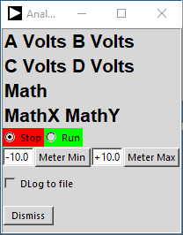 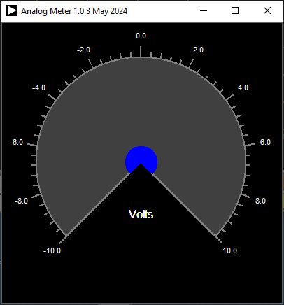

Set the ALICE Analog Meter Min to – 10.0 and the Meter Max to 10.0. Click Run. Adjust the CH A Offset entry so that the meter reading is as close to zero as possible. The mouse wheel will increase / decrease the digit next to the cursor or you can use the up and down arrow keys.

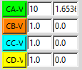 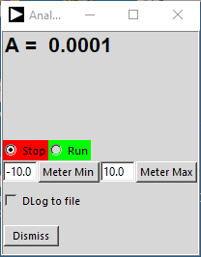

Disconnect the A+ input from ground. Connect the + terminal of the 9 V battery (red wire) to the A+ input of the board. Connect the – terminal of the 9 V battery (black wire) to GND. (A- input is still connected to one of the GND pins as shown below).

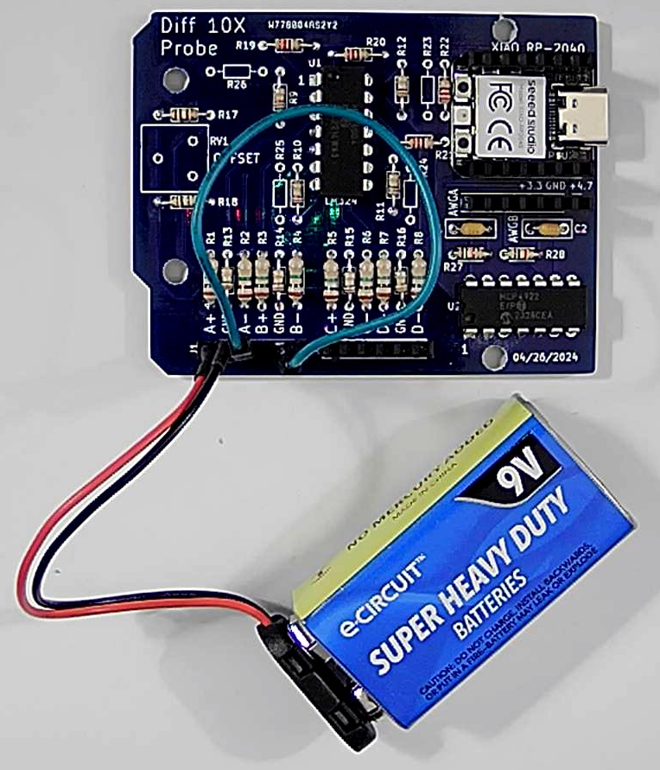

Battery connected to A+ and GND, A- connected to GND

Adjust the CA-V Gain setting so that the channel A voltage reading matches the voltage of the battery measured in the first step.

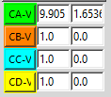 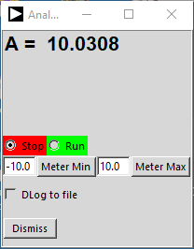

As a check to see if the Offset value is still correct for this new Gain value, disconnect + wire of the battery from A+ and connect A+ back to GND. The reading should still be very close to zero. (Adjust as necessary). Reconnect the + terminal of the battery to A+. Reading should again be the same as the before.

As a further check swap the + and – battery connections (A+ to – battery wire and GND to + battery wire). The reading in ALICE should be minus the battery voltage.

Repeat these steps for the remaining B, C and D channels using the B+ and B-, C+ and C-, D+ and D- input pins. When completed the calibrated Gain and Offset values for all four channels should be filled in. The values for each channel will of course be slightly different due to the matching of the resistors used in a given attenuator board.

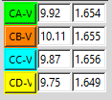

These adjustment settings are automatically saved in the alice-last-config.cfg file along with all the other configuration settings each time you exit ALICE. You can also save just the input gain and offset adjustment values in a separate file by clicking on the Save Adj button in the File Drop down menu. Clicking on the Load Adj button will load the saved values from the file.